ACCESSING GOOGLE MEET (SYNCHRONOUS "LIVE" SESSIONS)

Please check that your device has a microphone and camera and that both are working correctly. If you don't have a device that contains a microphone and/or camera, we suggest using a cell phone for live Google Meet sessions.

Option A:

1. Go to your Google Classroom to select a course
2. Click the link to join the meeting
3. You will be unable to join the meeting unless your teacher has already joined

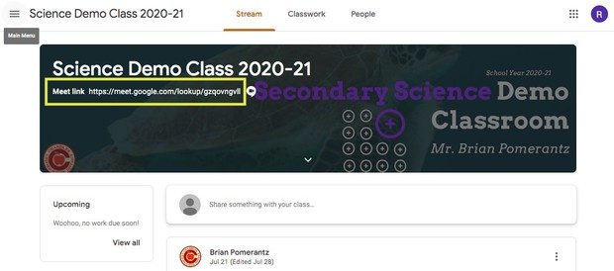

Option B:

1. Go to your Google Classroom to select a course
2. In the stream, you will see a message from your instructor with the join code or nickname for the Meet.
3. Go to [meet.google.com](http://meet.google.com/) and enter the code to join.

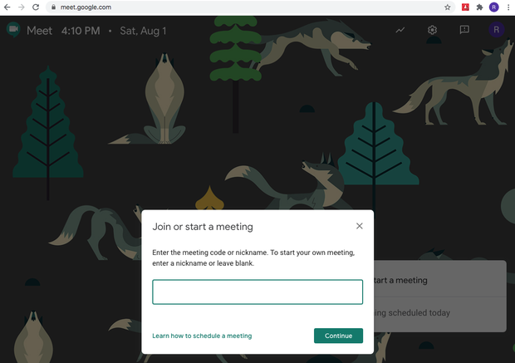

In the event you have any concerns or trouble accessing your Google Classrooms, please contact the office for assistance, (480) 424-8000.